**Experiment No: 12**

**Name of the Experiment:** Study Of Divided Difference Method To Predict Unknown Value(s) For Any Geographic Point Data.

**Objectives:** The objective of this experiment is to use divided difference method to find out the very precise values of the given data point, using MATLAB.

**Theory:** **xi** and **xj** are any two tabular points, is independent of **xi** and **xj**. This ratio is called the first divided difference of **f(x)** relative to **xi** and **xj** and is denoted by **f [xi, xj]**. That is

|  |  |  |
| --- | --- | --- |
| **f [xi, xj] =** | **f(xi) - f(xj)** | **=  f [xj, xi]** |
|  |
| **(xi - xj)** |

Since the ratio is independent of  **xi** and **xj** we can write   **f [x0, x] = f [x0, x1]**

|  |  |  |
| --- | --- | --- |
| **f(x) - f(x0)** |  |  |
|  | = | **f [x0, x1]** |
| **(x - x0)** |  |  |

**f(x)** = **f(x0)** **+** **(x - x0) f [x0, x1]**

|  |  |  |  |  |  |  |  |  |  |
| --- | --- | --- | --- | --- | --- | --- | --- | --- | --- |
| = | **1** | | | **f(x0)** | **x0 - x** | | |  | **f1 - f0** |  | **f0x1 - f1x0** |
|  |  |  | = |  | **x +** |  |
| **x - x0** | **f(x1)** | **x1 - x** |  | **x1 - x0** |  | **x1 - x0** |

So if **f(x)** is approximated with a linear polynomial then the function value at any point **x** can be calculated by using **f(x)  P1(x) = f(x0) + (x - x1) f [x0, x1]**

where **f [x0, x1]** is the first divided difference of  **f** relative to **x0** and **x1**.

Similarly if **f(x)** is a second degree polynomial then the secant slope defined above is not constant but a linear function of **x.** Hence we have

|  |
| --- |
| **f [x1, x2] - f [x0, x1]** |
|  |
| **x2 - x0** |

is independent of **x0, x1** and **x2**. This ratio is defined as second divided difference of **f** relative to **x0, x1** and **x2**. The secind divided difference are denoted as

|  |  |  |
| --- | --- | --- |
|  |  | **f [x1, x2] - f [x0, x1]** |
| **f [x0, x1, x2]** | = |  |
|  |  | **x2 - x0** |

Now again since **f [x0, x1,x2]** is independent of **x0, x1** and **x2** we have

**f [x1, x0, x] = f [x0, x1, x2]**

|  |  |  |
| --- | --- | --- |
| **f [x0, x] - f [x1, x0]** |  |  |
|  | = | **f [x0, x1, x2]** |
| **x - x1** |  |  |

**f [x0, x] = f [x0, x1] + (x - x1) f [x0, x1, x2]**

|  |  |  |
| --- | --- | --- |
| **f [x] - f [x0]** |  |  |
|  | = | **f [x0, x1] + (x - x1) f [x0, x1, x2]** |
| **x - x0** |  |  |

**f(x) = f [x0] + (x - x0) f [x0, x1] + (x - x0) (x - x1) f [x0, x1, x2]**

The **k**th degree polynomial approximation to **f(x)** can be written as

**f(x) = f [x0] + (x - x0) f [x0, x1] + (x - x0) (x - x1) f [x0, x1, x2]**   
**+ . . . + (x - x0) (x - x1) . . . (x - xk-1) f [x0, x1, . . ., xk].**

This formula is called Newton's Divided Difference Formula.

**Tool:** MATLAB Software

**Methodology:**

**MATLAB CODE:**

x=[-3 -1 0 3 5];

fx=[-30 -22 -12 330 3458];

n=size(x,2);

%array of zeros

dt=zeros(n+1,n+1);

%% inserting x and fx in dt

for i=1:n

dt(i,1)=x(i);

dt(i,2)=fx(i);

end

%% creating divided difference table

z=3;l=0;k=2;

for i=1:n-1

for j=k:n

dt(j,z)=(dt(i+1,z-1)-dt(i,z-1))/(dt(i+1,1)-dt(i-l,1));

i=i+1;

if(i>=n)

break;

end

end

k=k+1;l=l+1;z=z+1;

end

%value for fining fx

x_int=2.5;

%% determining sum by formula

y_sum=dt(1,2);

for i=2:n

d=1;

for j=1:i-1

d=d*(x_int - x(j));

end

y_sum=y_sum+dt(i,i+1)*d;

end

%% result

dt

y_sum

%% ploting the graph

plot(x, fx, 'bo', x_int, y_sum, 'ro')

axis([-10 10 -1000 4000])

xlabel('x')

ylabel('y')

**Output:**

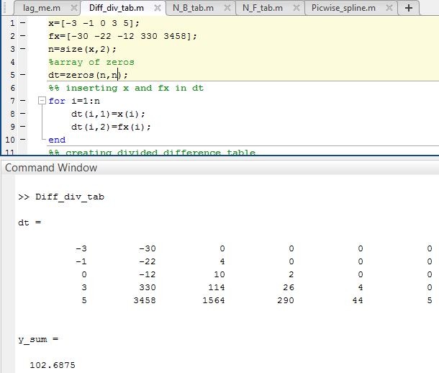

**------------------------------------------------------**

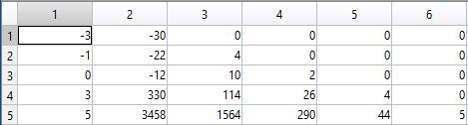

**Figure 12.1: Table of Newton Divided Difference**

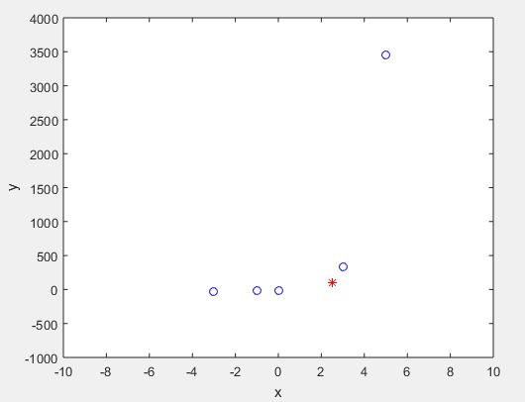

**Figure 12.2: Graph Of The Function**

**Result(s)& Discussion:** The unknown values for x = 2.5 is y = 102.6875 . From text book[1] for x=2.5 is y=102.7

**Conclusion:** We have found the approximate unknown value for 2.5 which is same as text book[1]. Matlab read the exact result 102.6875.

**References:**

[1]C. Chapra and P. Canale Raymond , “*Numerical Methods for Engineers”,* 7th ed. McGraw-Hill Education, 2 Penn Plaza, New York, NY 10121, 2015